FREEHOLD SHOP TOGETHER WITH
A 1 BEDROOM FLAT OVER

HUMMERSTONE & HAWKINS
www.hummerstone.co.uk

Est. 1925
cccccxmnsdfkjkjdfjnrvvvvvvvvvvcvvbfbcz

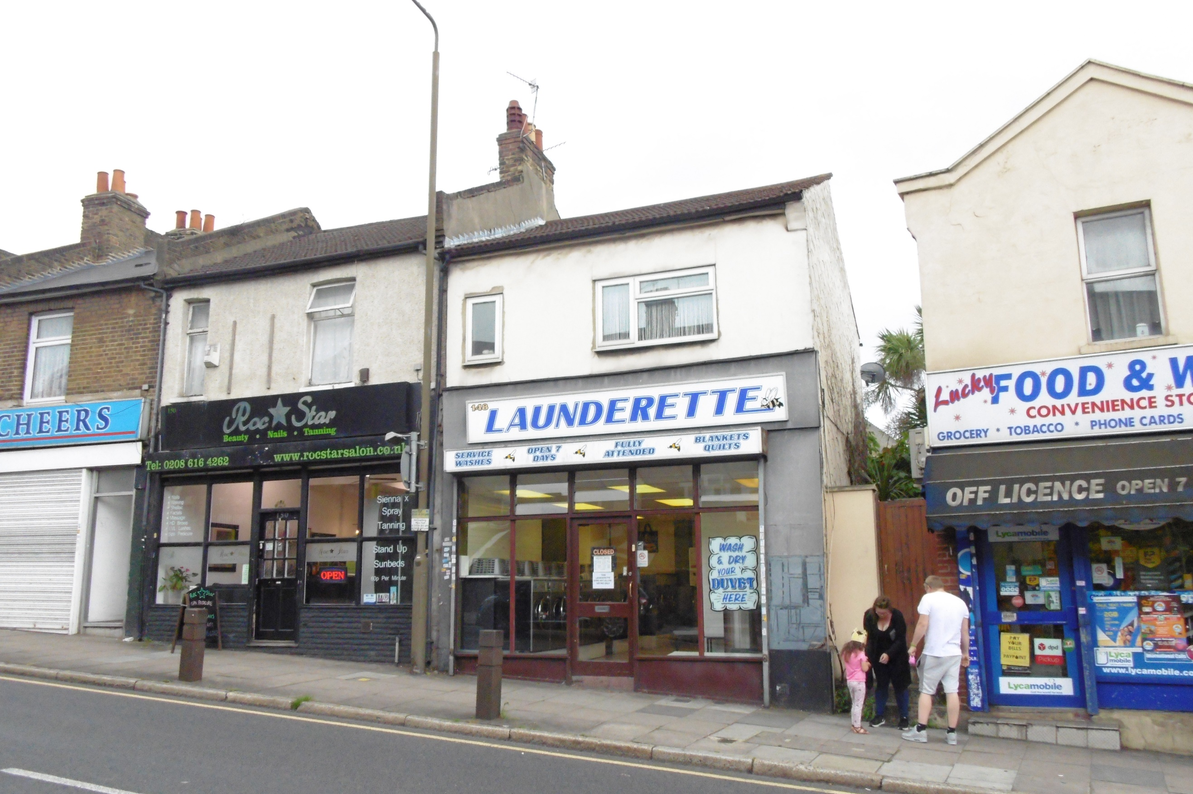

TWO STOREY BUILDING / D1 USE 12 THE SLADE

148 & 148A PLUMSTEAD COMMON ROAD
PLUMSTEAD, SE18 2UL

FREEHOLD

GUIDE PRICE £415,000

HUMMERSTONE & HAWKINS
0208 303 1061

- RETAIL PREMISES WITH SALES AREA 425 SQ FT

- WELL PRESENTED & GOOD SIZED 1 BED FLAT OVER

- SOUGHT AFTER & POPULAR LOCATION

- POTENTIAL DEVELOPMENT OPPORTUNITY BOTH TO REAR & ON FIRST FLOOR.

EPC: SHOP – D 84 / FLAT D 62
PLUMSTEAD SE18 2NB 190 SQ M/2,045 SQ FT
PARKING SPACES TO FRONT
SMALL REAR GARDEN
EPC FREEHOLD
PRICE £795,000

LOCATION:
Plumstead is a district of South East London located in the London Borough of Greenwich. It is located some 2 miles east of Woolwich, approx. 3.5 miles north-west of Bexleyheath and around 2 miles north of Welling.

The subject building is situated fronting on to Plumstead Common Road, a busy road carrying high volumes of traffic and linking the South Circular Road and the A209. The property itself has good signage and is clearly visible to traffic travelling in both directions and it forms part of a neighbourhood shopping centre where other businesses in the vicinity include a Co-op Food store, an Esso petrol forecourt and a number of independent retailers. The area immediately surrounding is predominately residential.

Recreation facilities can be nearby at Plumstead Common.

DESCRIPTION:
An end terraced two storey building forming part of a busy neighbourhood shopping centre and which has trading as a laundrette for over 40 years. The property has been in the hands of our clients, who have decided to retire, since the 1990’s.

GROUND FLOOR
A single entrance door leads in to the main rectangular shaped retail area of approximately 425sq.ft / 39.5sq.m. Behind there is a kitchen of approximately 46sq.ft / 4. 3sq.m, a boiler room of 99sq.ft / 9.2 sq.m and a store room 97sq.ft / 9 sq.m

The property includes a rear yard which can be accessed either from the shop or via Jago Road.

ACCOMODATION
Access is at the rear of the building via an external staircase up to a private entrance door leading in to a well-presented self-contained flat which we understand has recently been refurbished and decorated.

The accommodation comprises:
Fitted kitchen (101sq.ft)
Lounge ( 205sq.ft)
Double bedroom (118sq.ft)
Bathroom ( 56sq.ft)

ADDITIONAL COMMENTS:
The property is being sold chain free with full vacant possession, although if an applicant was keen on continuing with the laundrette business then our clients would be happy to discuss this further.
With Plumstead being an area of high demand, this opportunity may suit an investor or be ideal for an owner operator who wants the chance to add to an existing portfolio, start a new business venture or looking for office space.

PLANNING:
In May 2016 planning was approved to extend the first floor flat. It was granted on the basis that the work would have to commence within 3 years.

In 2016 planning was declined for the erection of a single storey rear extension to create a one-bedroom self-contained unit. The application was refused due to the size falling below the minimum standard. A new application could be looked into and submitted.

TENURE:
We understand that the property is freehold.

EPC:
148 Plumstead Common Road – D 64
148a Plumstead Common Road - D 62

RATES:
We understand that the rateable value is £5,900 per annum. Interested parties are advised to make their own enquiries with the relevant council as to rate relief.

LEGAL FEES:
Each party are to be responsible for their own legal costs.

VIEWING ARRANGEMENTS:
No direct approach may be made to the property / business. For an appointment to view, please contact the agent.

Hummerstone & Hawkins
144 Welling High Street

Welling, DA16 1TN

T: 0208 303 1061
E: agency@hummerstone.co.uk

