RETAIL SHOP IN BEXLEYHEATH TO LET

HUMMERSTONE & HAWKINS
www.hummerstone.co.uk

Est. 1925
cccccxmnsdfkjkjdfjnrvvvvvvvvvvcvvbfbcz

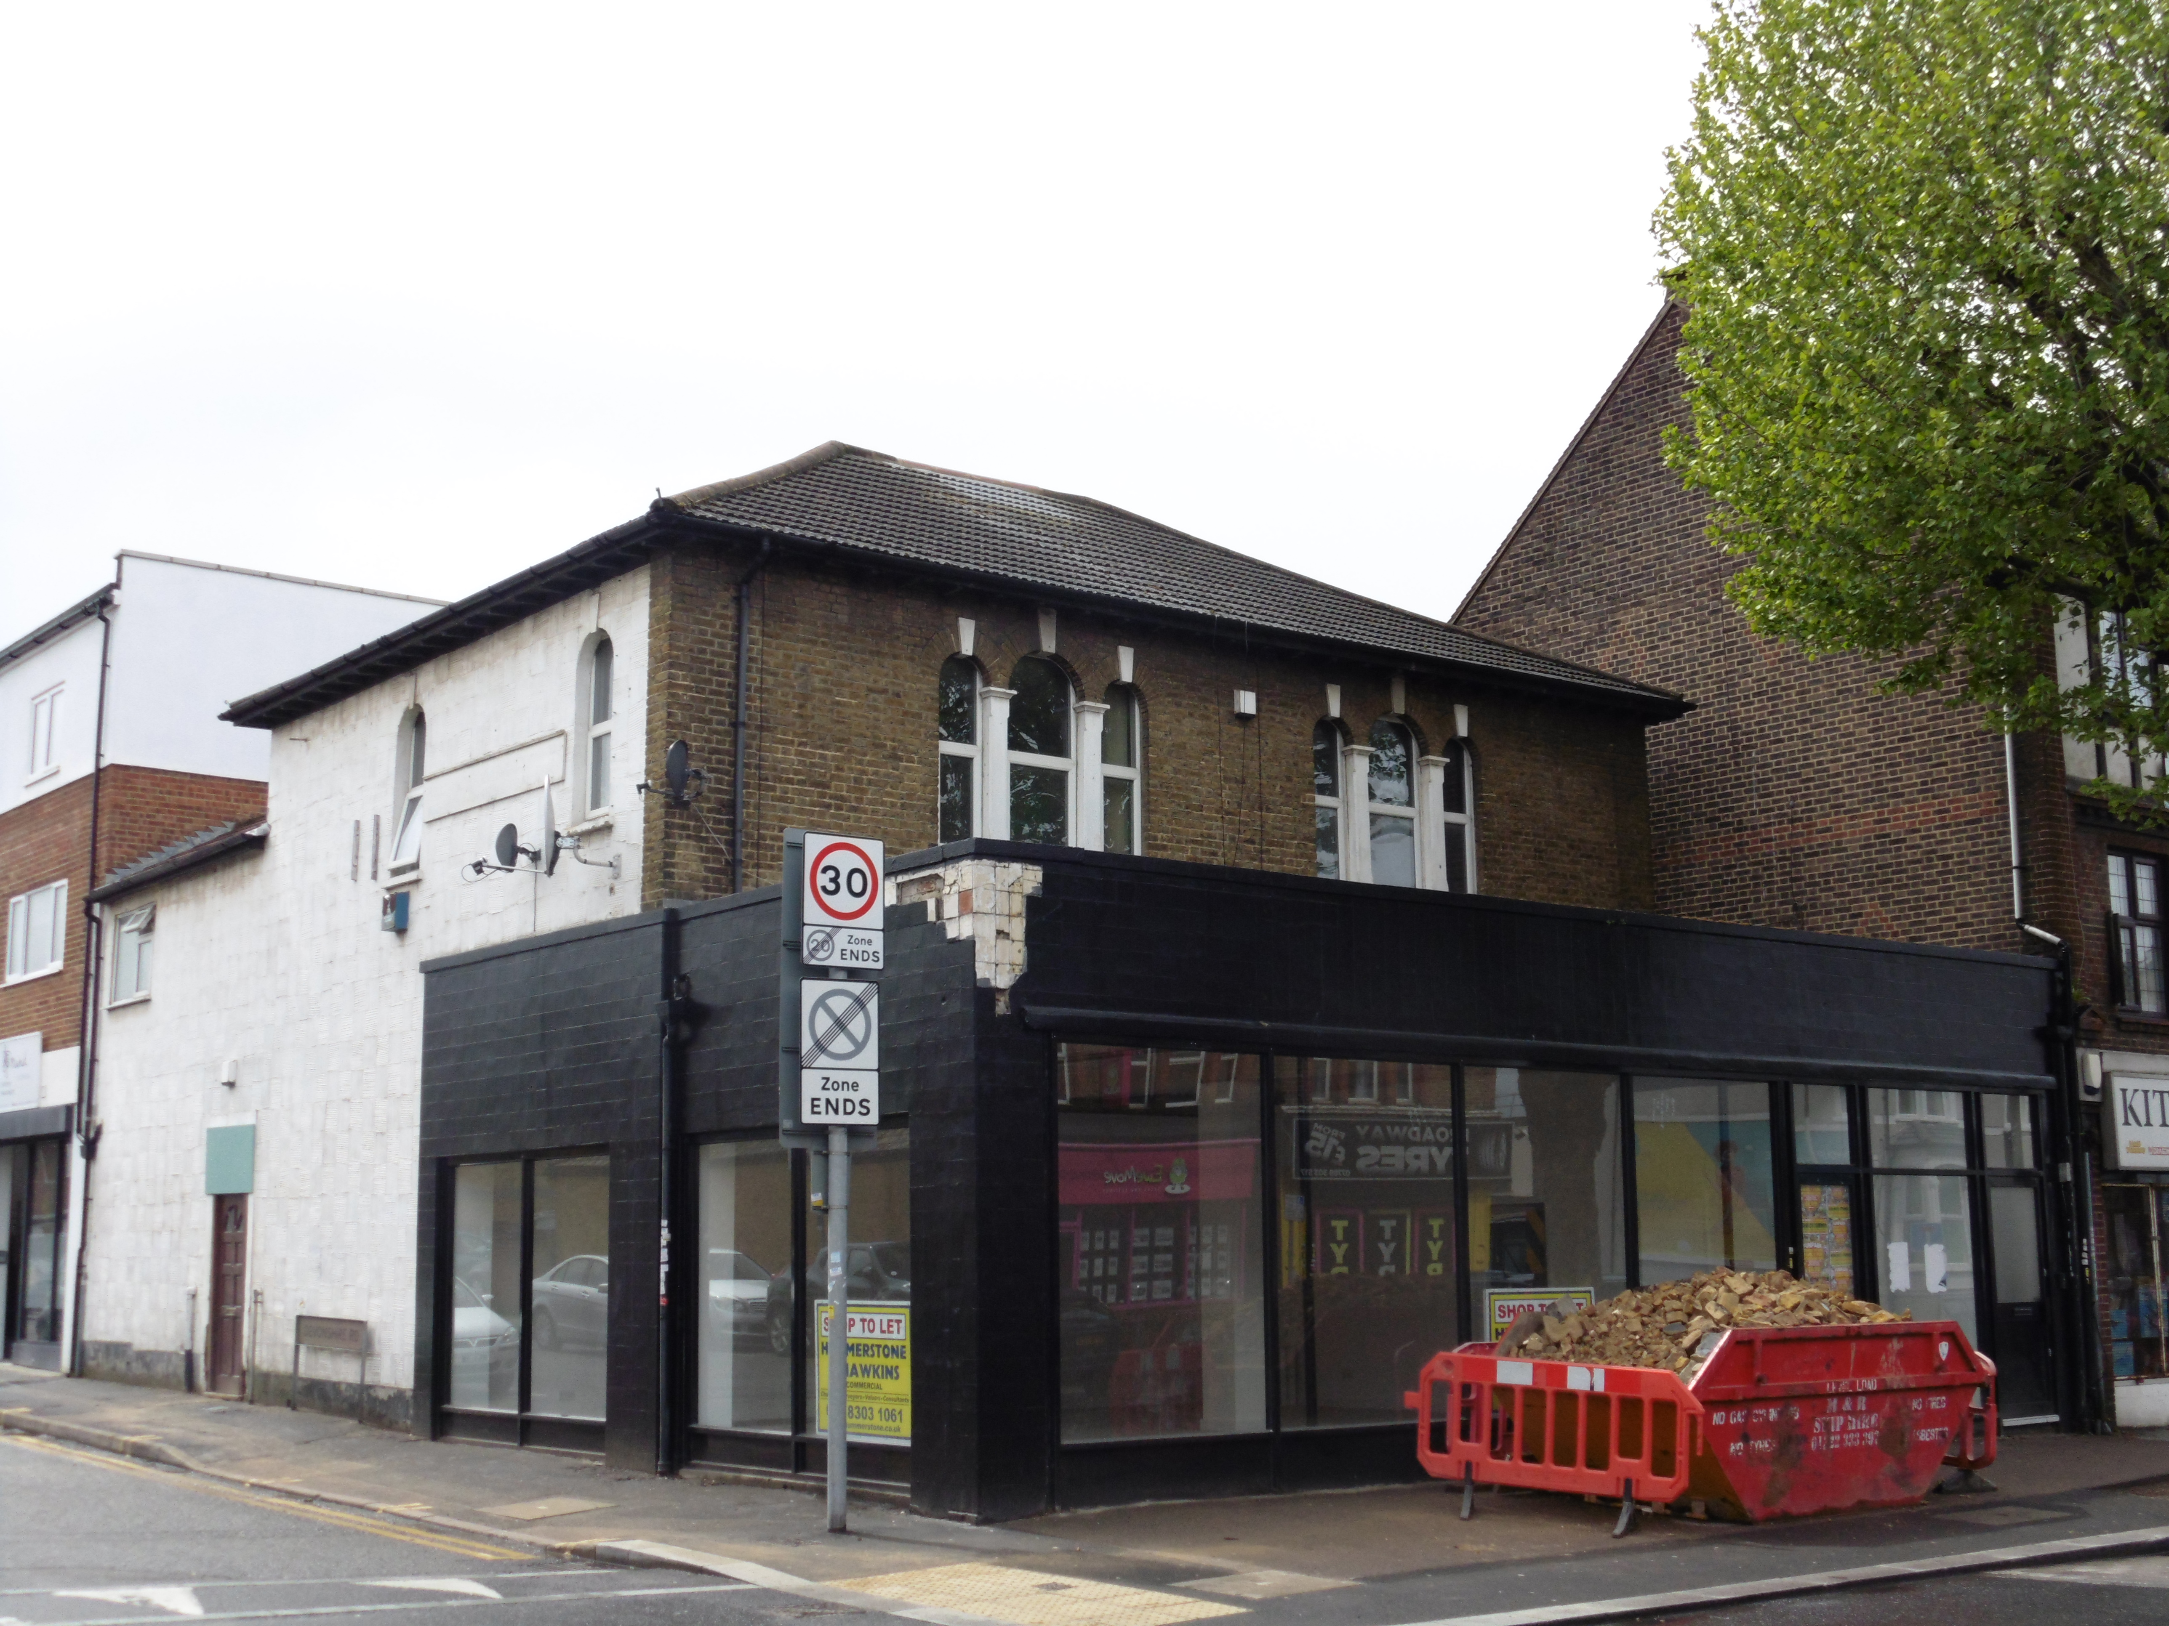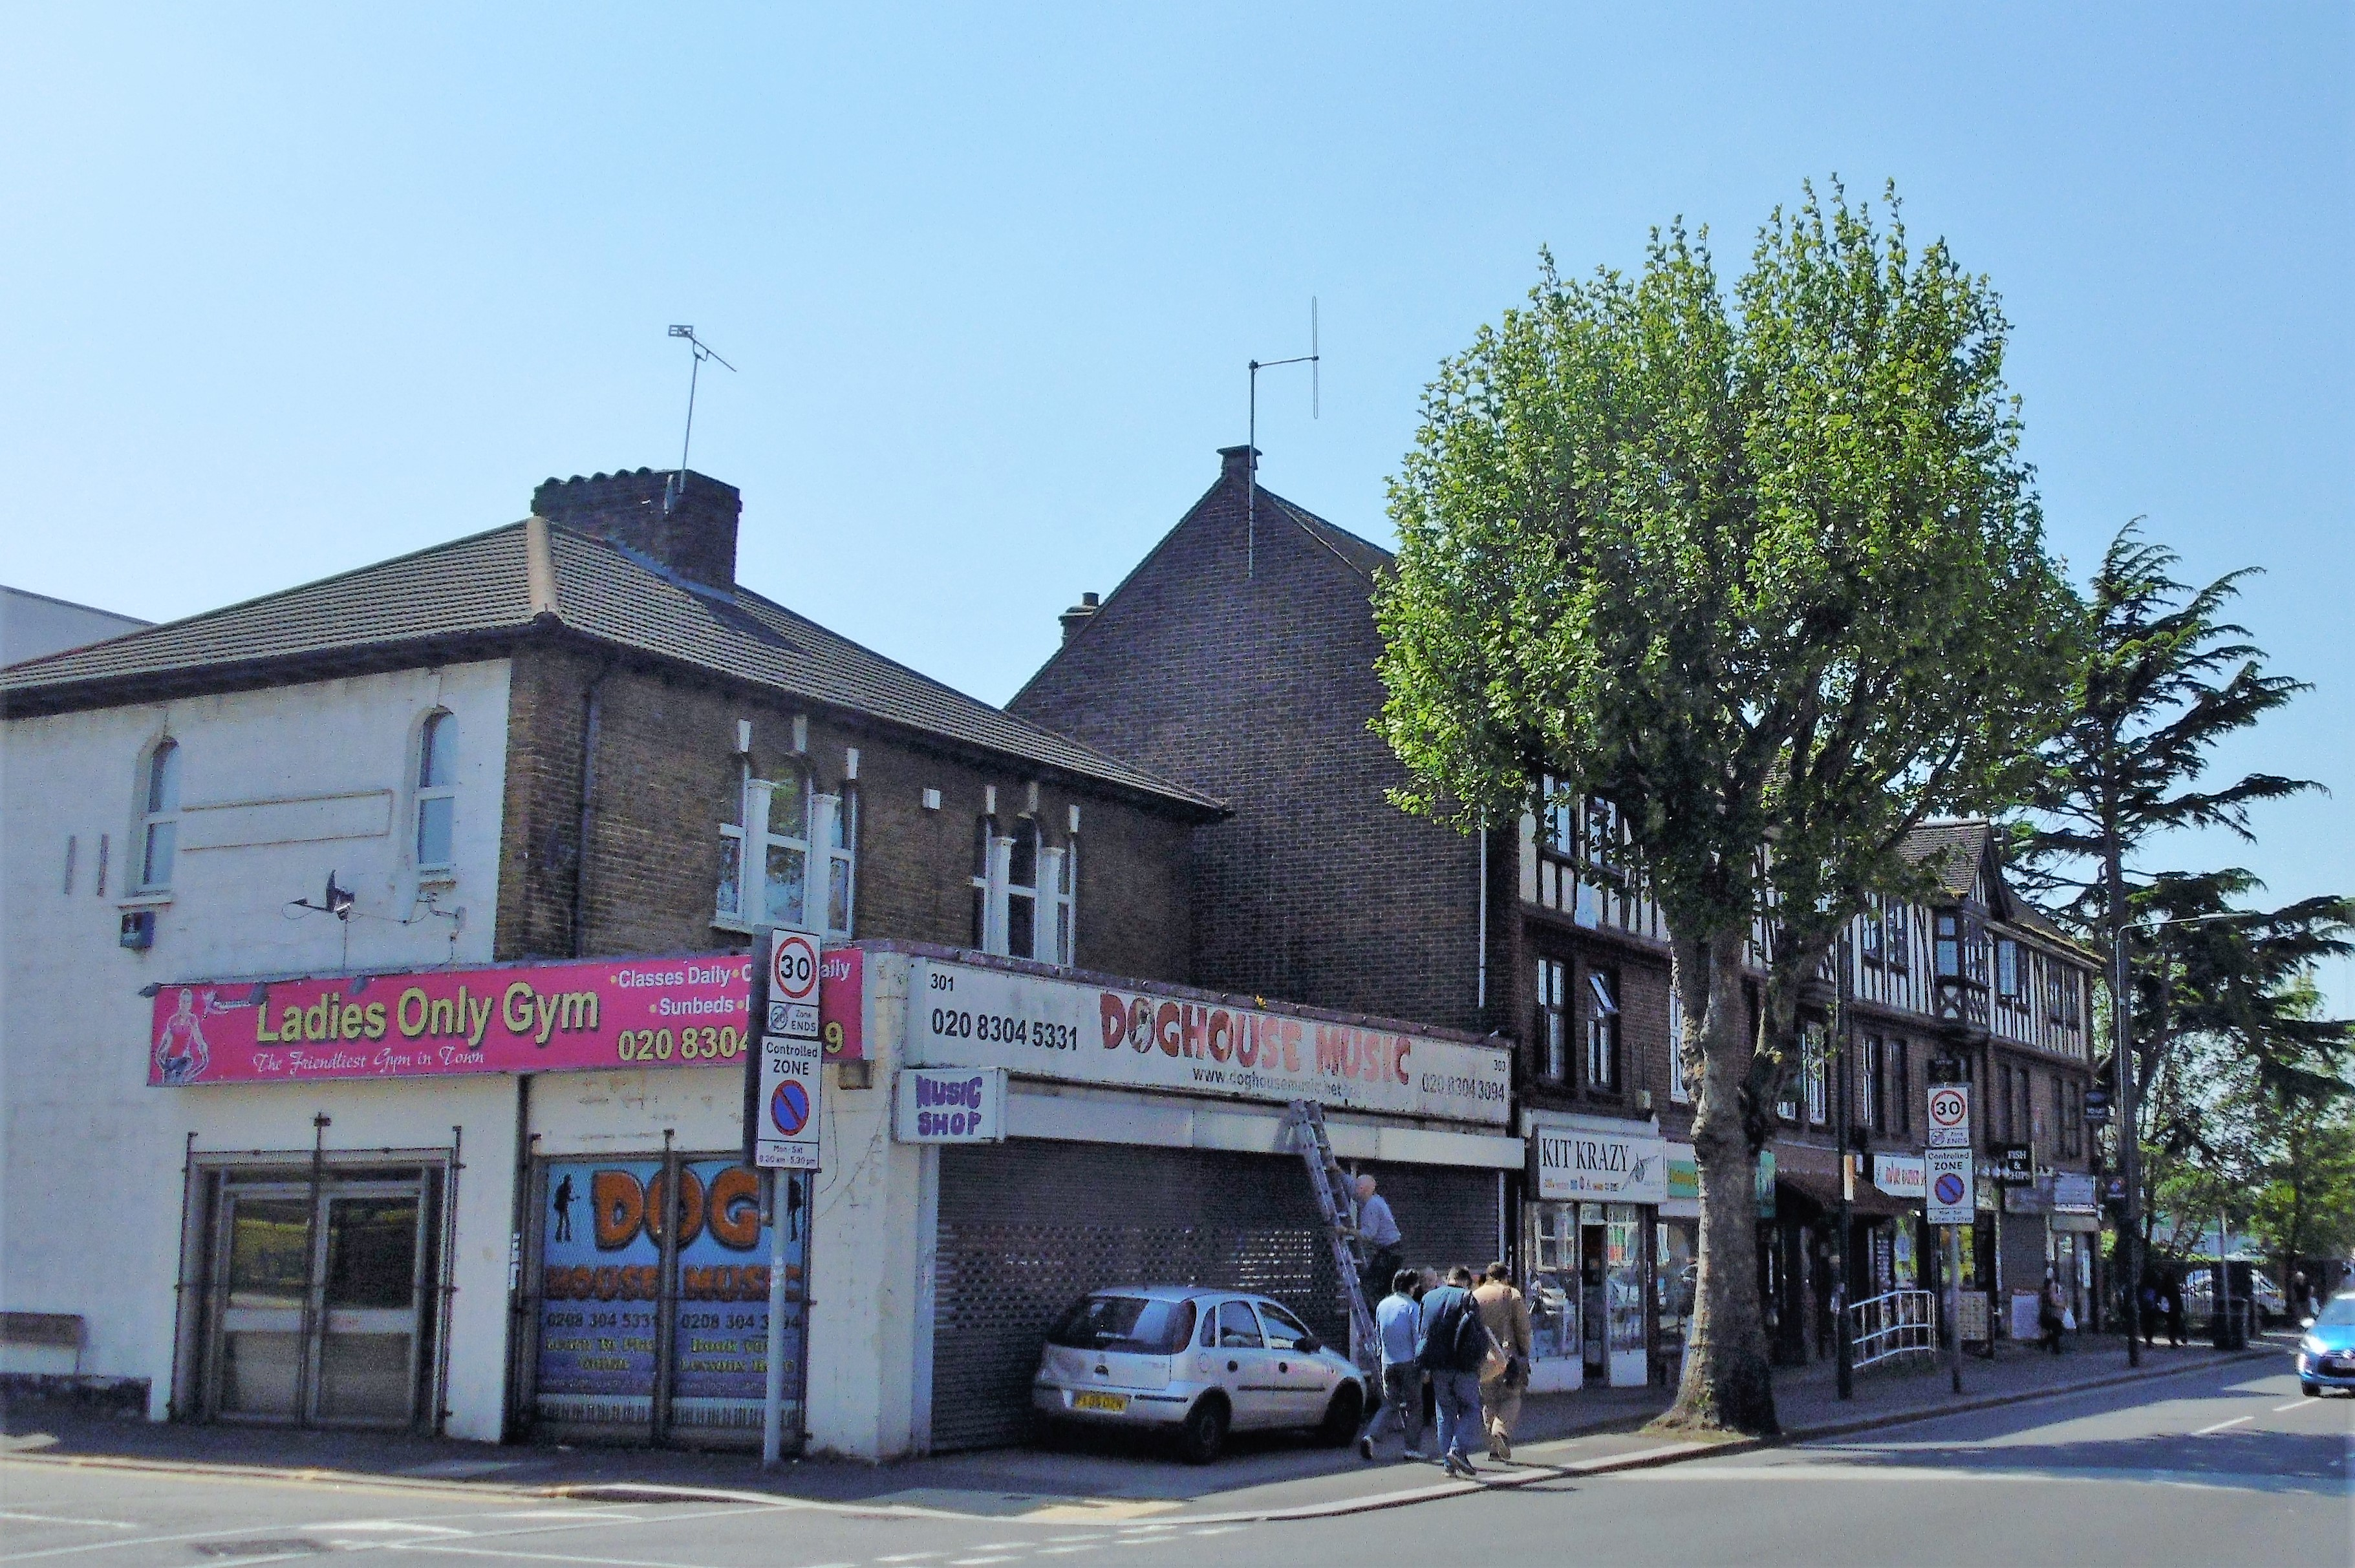

TWO STOREY BUILDING / D1 USE 12 THE SLADE

301 – 303 BROADWAY
BEXLEYHEATH,
DA6 8DT

TENURE: NEW LETTING

RENTAL: £26,000PA

HUMMERSTONE & HAWKINS
0208 303 1061

- RETAIL SHOP BENEFITTING FROM A PROMIENT CORNER POSTION,

- FLOOR AREA APPROACHING 890 SQ. FT. / 82 SQ. M.

- SUBSTANTIAL PASSING TRADE / CLOSE TO TOWN & STATION

- PREMISES RECENTLY REFURBISHED

PLUMSTEAD SE18 2NB 190 SQ M/2,045 SQ FT
PARKING SPACES TO FRONT
SMALL REAR GARDEN
EPC FREEHOLD
PRICE £795,000

LOCATION:
The subject property enjoys a prominent trading position on the corner of Devonshire Road & fronting on to the busy Broadway. The area immediately surrounding the property comprise a mix of both commercial and residential properties. The unit benefits from substantial passing trade with the Broadway being a main thoroughfare carrying traffic travelling to and from Bexleyheath town centre. The Broadway is also a main bus route. The town has a busy shopping centre with a good mix of both local and national retailers. There are good road links to the A2 trunk road linking London and the South.

DESCRIPTION:
The subject premises comprise of a refurbished ground floor lock up shop which enjoys and benefits from a prominent corner position and return frontage. A single entrance door leads in to an open plan retail sales area of approximately 890 square feet / 82 square metres. As you enter to the right-hand side there’s access to a small kitchen area together with a staff toilet

For deliveries to the premises, and for customers using the shop there is metered parking along Devonshire Road.

We feel that the premises may suit a variety of retail uses or possibly office space.

TENURE:
The premises are available on a new lease, the terms of which are open to negotiation, and at a commencing rental of £26.000pa. exclusive of rates.

A rental deposit will be required subject to status

EPC RATING:
E – 101

RATES:
We understand that the rateable value is £16,500 per annum with rates payable of £7,920 per annum. Interested parties are advised to make their own enquiries with the relevant council.

LEGAL FEES:
Each party are to be responsible for their own legal costs

VIEWING ARRANGEMENTS:
No direct approach may be made to the property / business. For an appointment to view, please contact the agent.

Hummerstone & Hawkins
144 Welling High Street

Welling, DA16 1TN

T: 0208 303 1061
E: agency@hummerstone.co.uk

