-
FREEHOLD PROPERTY IN PLUMSTEAD FOR SALE

HUMMERSTONE & HAWKINS
www.hummerstone.co.uk

Est. 1925
cccccxmnsdfkjkjdfjnrvvvvvvvvvvcvvbfbcz

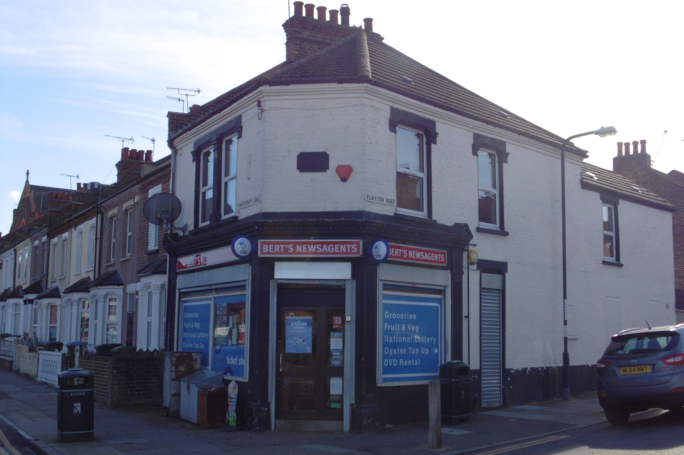

TWO STOREY BUILDING / D1 USE 12 THE SLADE

112 Timbercroft Lane
Plumstead,
SE18 2SG

TENURE: FREEHOLD

ASKING PRICE: £POA

HUMMERSTONE & HAWKINS
0208 303 1061

- GROUND FLOOR CONVENIENCE STORE

- RESIDENTIAL ACCOMODATION ARRANGED OVER FIRST FLOOR

- WITHIN A DENSLEY POPULATED RESIDENTIAL AREA

- SALES AREA OF APPROX. 540 SQUARE FEET / 50.2 SQUARE METRES
PLUMSTEAD SE18 2NB 190 SQ M/2,045 SQ FT
PARKING SPACES TO FRONT
SMALL REAR GARDEN
EPC FREEHOLD
PRICE £795,000

LOCATION:
Plumstead is a district of South East London located in the London Borough of Greenwich. It is located some 2 miles east of Woolwich, approx. 3.5 miles north-west of Bexleyheath and around 2 miles north of Welling.

The subject property enjoys a prominent trading position on the corner of Timbercroft Lane and Flaxton Road, directly opposite Timbercroft Primary School. Immediately surrounding is essentially a densely populated residential area.

DESCRIPTION:
The subject property comprises an end terrace two storey property constructed circa 1890 with on the ground floor a lock up retail premises with a residential flat above.

We understand that the property has been in the same family hands for the past 60 years in which time the retail premises has traded as a neighbourhood convenience store.

Ground floor
A single entrance door leads in to a retail area of approximately 540sq.ft (50.2 sq. m). Behind the sales area is a kitchen 135sq.ft (12.5 sq. m) and a staff toilet.

First floor
Arranged over the first floor is a residential flat which is accessed via its own private entrance door at the rear of the property.

TENURE:
We are informed that the property is freehold.

EPC:
D - 90

RATES:
We understand that the rateable value is £5,100 per annum and therefore should qualify for small business rate relief.

LEGAL FEES:
Each party are to be responsible for their own legal costs

VIEWING ARRANGEMENTS:
No direct approach may be made to the property / business. For an appointment to view, please contact the agent.

Hummerstone & Hawkins
144 Welling High Street

Welling, DA16 1TN
T: 0208 303 1TN

