FREEHOLD BUNGALOW PLUS ADJOINING GARDEN LAND

HUMMERSTONE & HAWKINS
www.hummerstone.co.uk

Est. 1925
cccccxmnsdfkjkjdfjnrvvvvvvvvvvcvvbfbcz

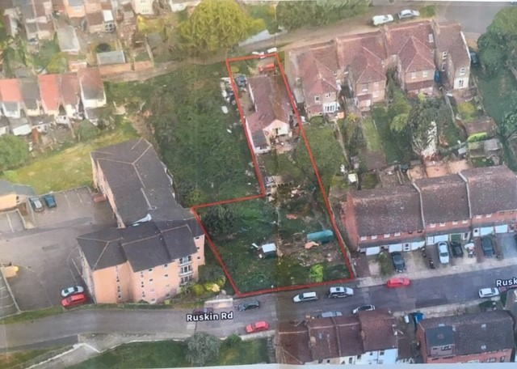

TWO STOREY BUILDING / D1 USE 12 THE SLADE

98 MILTON ROAD
BELVEDERE
DA17 5BA

FREEHOLD
£525,000

HUMMERSTONE & HAWKINS
0208 303 1061

- 2 BEDROOM BUNGALOW + ADJOINING GARDEN LAND HELD ON POSSESSORY TITLE

- SITE INCLUDING BOTH PLOTS CIRCA .27 ACRES.

- OFFERS TO PURCHASE ON SEPARATE TITLES

- NEW BUILD SCHEMES CONSENTED NEARBY / RESIDENTIAL AREA

PLUMSTEAD SE18 2NB 190 SQ M/2,045 SQ FT
PARKING SPACES TO FRONT
SMALL REAR GARDEN
EPC FREEHOLD
PRICE £795,000

LOCATION:
Belvedere is a town located within the London Borough of Bexley which lies south of the River Thames and is some 17 miles east of Charing Cross. The town is situated some 5.2 miles north of Dartford, around 3 miles north of Bexleyheath and approximately 4.7 miles east of Woolwich.

The site is in close proximity of two mainline train stations with Belvedere Station around 0.5 miles away where there is a frequent service in to London Charing Cross (39 mins) and to London Cannon Street (37 mins). Abbey Wood Station is around 1 mile away which in the future will benefit from Crossrail services which will enable commuters to travel to Canary Wharf (approx. 11 mins) and Bond Street (approx. 25 mins).

Nuxley Village, Upper Belvedere is an approximate 10 minute walk from the site where the busy shopping street comprises predominately of independent and specialist operators plus national retailers including Sainsbury’s, Lloyds Bank, Paddy Power, Coral and a Cooperative Supermarket.

There are several bus stops near to Milton Road which provide services Belvedere, Bexleyheath and Woolwich.

DESCRIPTION:
An excellent opportunity to acquire a 2 bedroom detached bungalow which is situated on a good sized plot which is in need of refurbishment but may offer some future development potential (STPP).
The property together with the adjoining garden land which is held on separate possessory title runs between Milton Road and Ruskin Road with the bungalow fronting on to and accessed via Milton Road.

The bungalow, which needs total refurbishment and decoration offers:
Entrance hall 100 Sq. ft
Bedroom 1 144 Sq. ft
Bedroom 2 144 Sq. ft
Kitchen 95 Sq. ft
Dining area 108 Sq. ft
Rear lounge 208 Sq. ft

PLANNING:
We understand that no applications have been made to develop this site.
Planning in the area includes approval in 2017 for the land adjoining to the side of 98 Milton Road for a part two/part three storey building comprising 7x2 bedroom flats together with 7 parking spaces.
Ruskin Road provides access to Samson Court., which is a development situated adjacent to the subject site comprising a modern four storey apartment block.

TENURE:
We are informed that the property is freehold

VAT:
We understand that VAT is not applicable in this transaction

AGENTS COMMENTS:
At the time of our inspection our clients advised us that there is a claim for adverse possession on part of the site backing on to Ruskin Road which is held under possessory title – further details are available upon request.

We understand that our clients are happy to discuss with any interested parties the possibility of them offering an indemnity insurance or selling the opportunity under separate titles.

LEGAL FEES:
Each party are to be responsible for their own legal costs

VIEWING ARRANGEMENTS:
No direct approach may be made to the property. For an appointment to view, please contact the agent.

Hummerstone & Hawkins
144 Welling High Street

Welling, DA16 1TN

T: 0208 303 1061
E: agency@hummerstone.co.uk

