WAREHOUSE & OFFICES WITH PARKING TO LET
HUMMERSTONE & HAWKINS
www.hummerstone.co.uk

Est. 1925

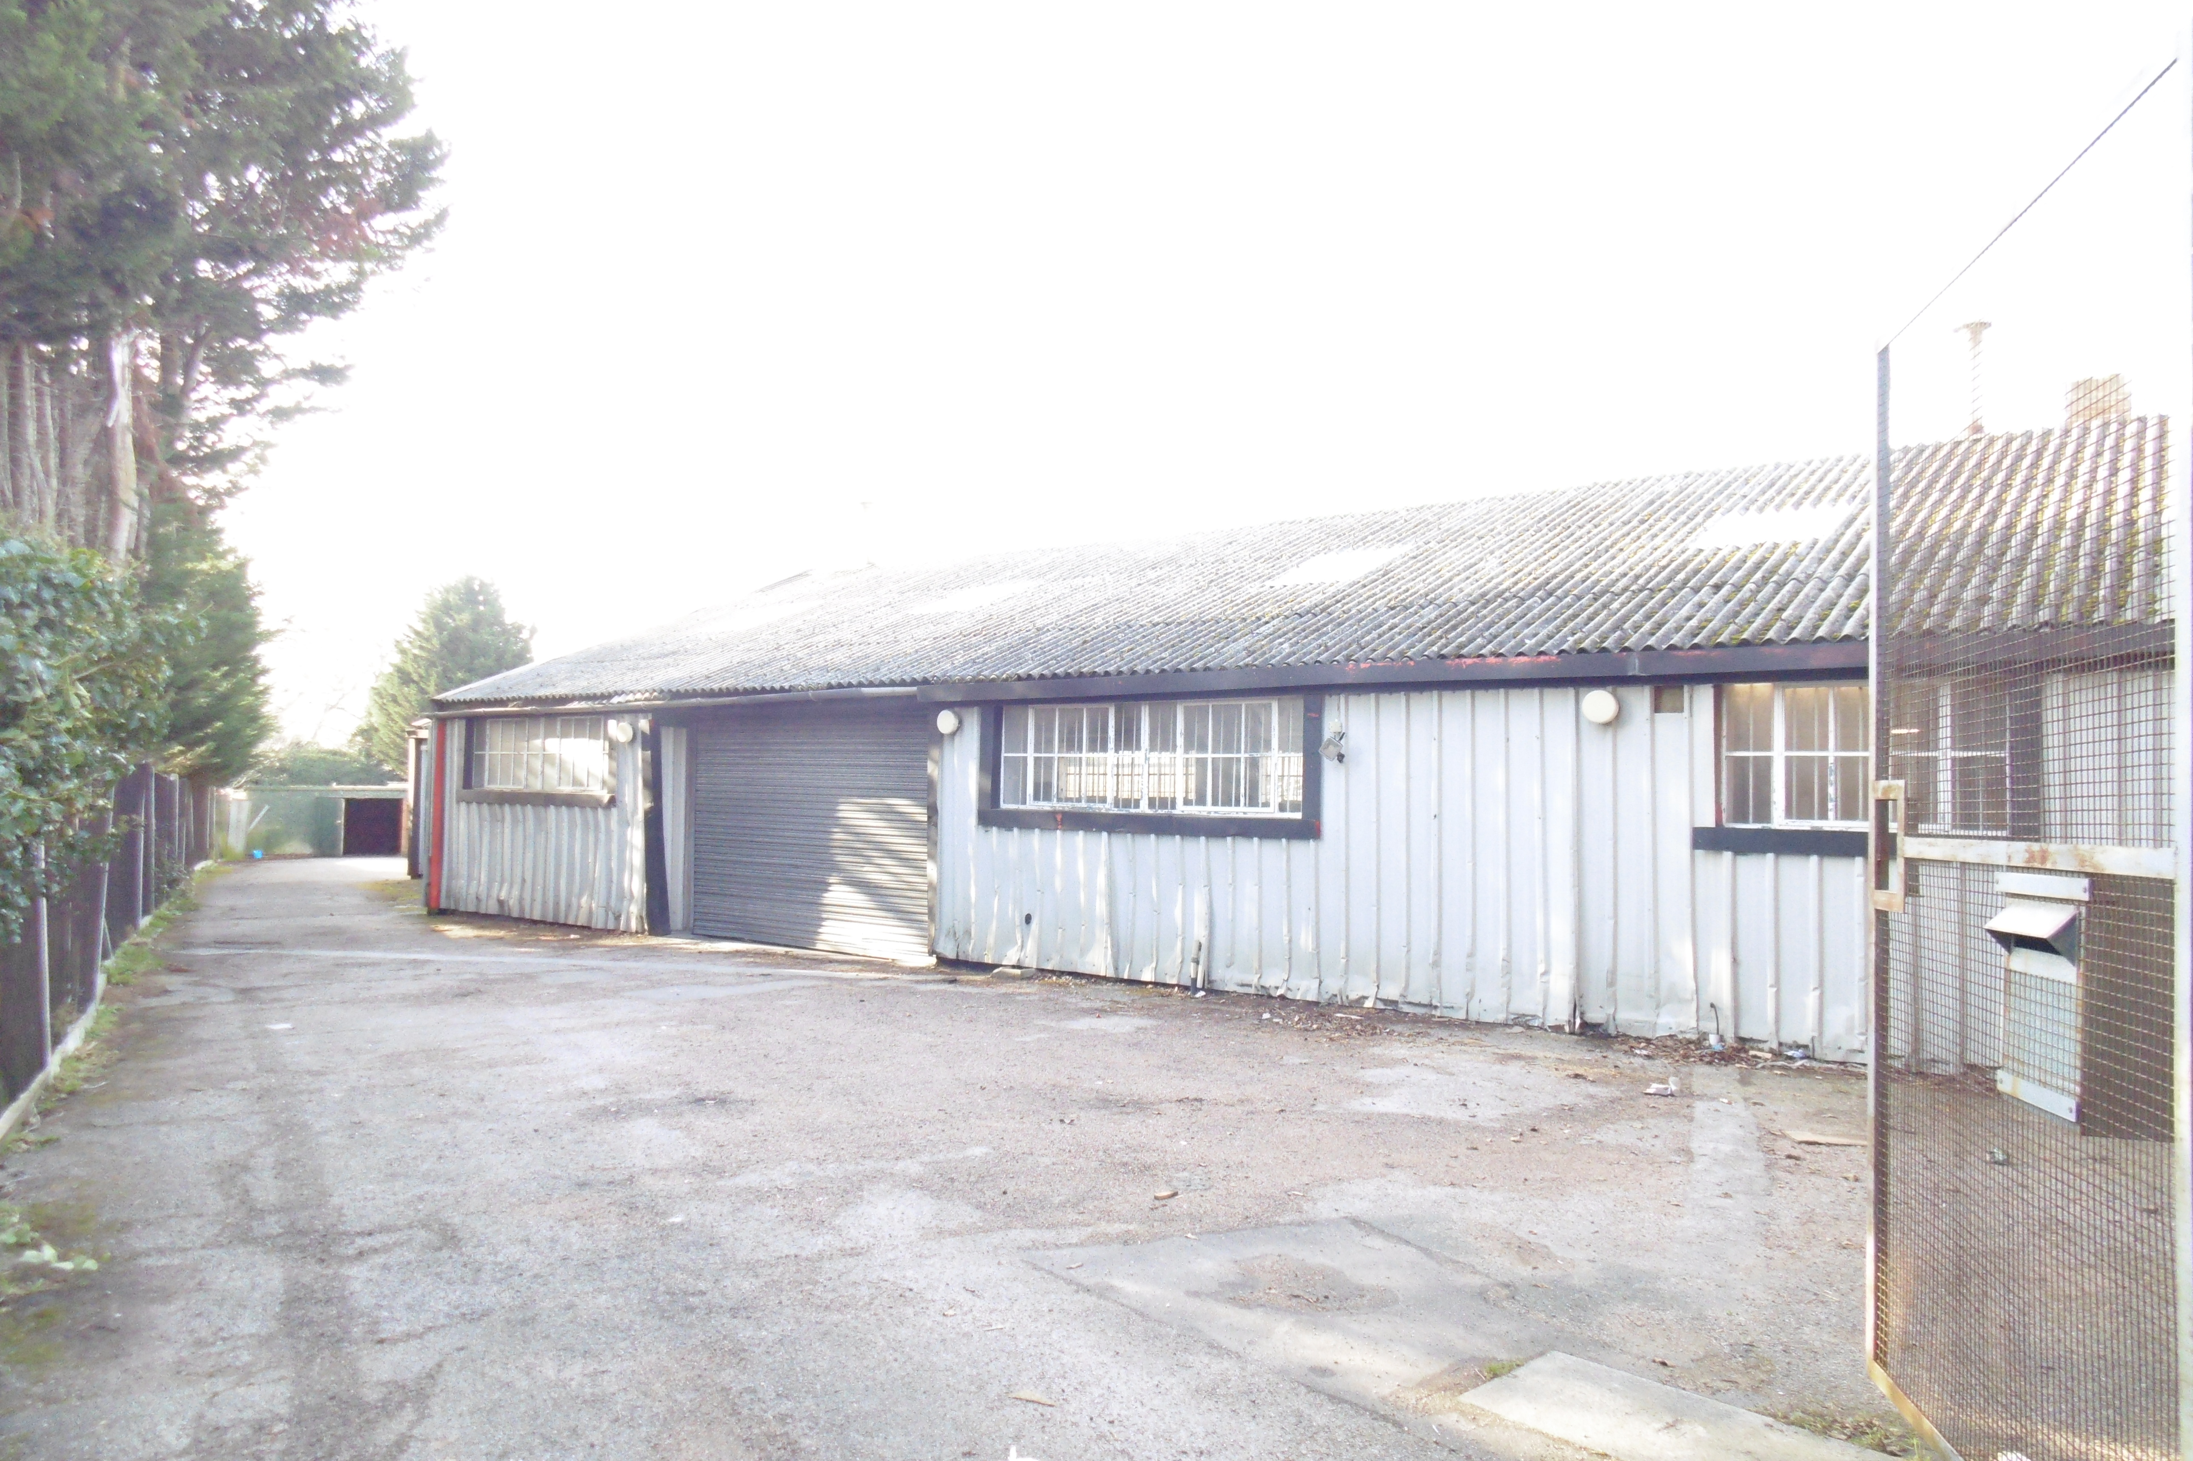

SINGLE STOREY WAREHOUSE & OFFICES | 168 BLACKFEN ROAD
WAREHOUSE AREA OF 2,139 SQUARE FEET | BLACKFEN
OFFICES OF 573 SQUARE FEET | DA15 8PT
PARKING FOR NUMEROUS VEHICLES | Tenure: TO LET
CEILING HEIGHT OF WAREHOUSE 5.23 M | Rental: £38,000 per annum
AVAIALABLE ON A NEW LEASE | Hummerstone & Hawkins  0208 303 1061
LOCATION:
Blackfen is a largely residential area of South East London within the London Borough of Bexley and is located some 3 miles north of Sidcup, 1 mile south of Welling, and around 2 miles west of Bexleyheath

The area has excellent road links with the A210 (Blackfen Road) running in a westerly direction to Eltham and an easterly direction to Bexley. The main A2 trunk road passes close by where connects can be made to the M25 and Dartford Crossing.

Blacken has an extremely busy shopping centre with businesses in the area including a Coop supermarket, Tesco’s Express, Costa Coffee, Betfred, Coral and numerous independent and specialist retailers.

The subject property enjoys a more secluded spot just off Blacken Road with access via Hawthorn Terrace.

DESCRIPTION:
The property is a single storey warehouse with rear office and storage space. Within the premises is a gallery kitchen plus separate ladies and gents toilets.

The property includes to the side an electric motor rolled shutter access for loading and deliveries.

Behind the property is ample parking for several vehicles plus an outside storage shed.

INTERNAL DETAILS:
Warehouse 2,139 square feet (Maximum ceiling height of 17’)
Office space 573 square feet
Kitchen 80 square feet
2 Toilets 118 square feet

TENURE:
The premises are available by way of a new full repairing and insuring lease at a commencing rental of £38,000.
.
EPC:
The premises has an EPC rating of E - 118

RATES:
We understand that the rateable value is £20,500 per annum with rates payable of £8,791.31 per annum. Interested parties are advised to make their own enquiries with the relevant council.

LEGAL FEES:
Each party are to be responsible for their own legal costs

VIEWING ARRANGEMENTS:
No direct approach may be made to the property / business. For an appointment to view, please contact the agent.
Hummerstone & Hawkins T: 0208 303 1061

