RETAIL / OFFICE PREMISES IN BEXLEYHEATH TO LET
HUMMERSTONE & HAWKINS
www.hummerstone.co.uk

Est. 1925

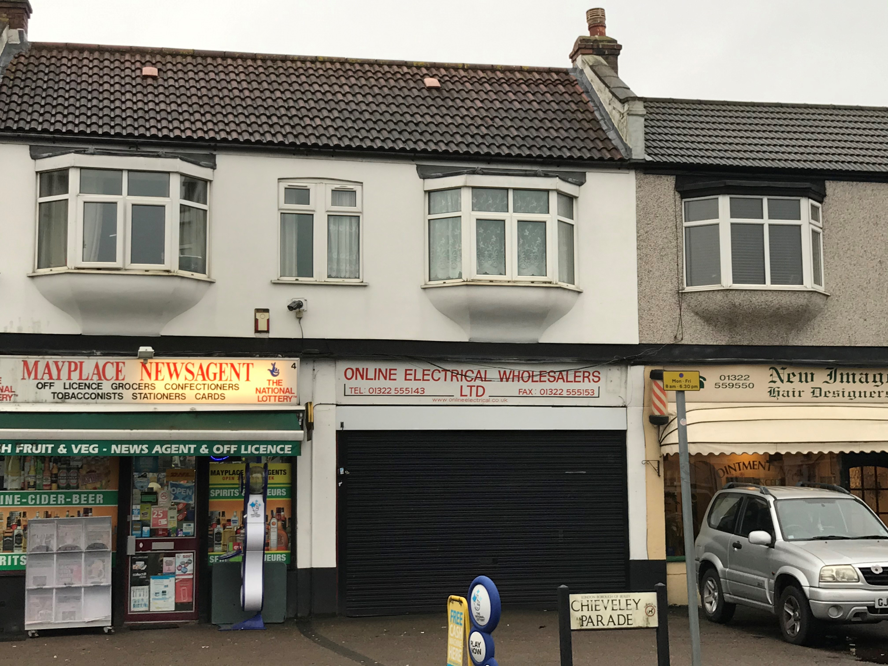

RETAIL / OFFICE PREMISES TO LET  AT A MODEST RENT OF £9,500 PA | 3 CHIEVELY PARADE
TOTAL FLOOR AREA OF AROUND 330 SQUARE FEET | MAYPALCE ROAD EAST
PREMISES FORM PART OF A SMALL SHOPPING PARADE | BEXLEYHEATH, DA7 6EB
RESIDENTIAL CATCHMENT AREA ON OUTSKIRTS OF THE TOWN CENTRE | Tenure TO LET
INCLUDES A FRONT FORECOURT PROVIDING STAFF PARKING SPACE | Rental £9,500 PER ANNUM
OFFERED WITH BENEFIT OF A NEW LEASE / TERMS TO BE AGREED. | Hummerstone & Hawkins 0208 303 1061

LOCATION:
Chieveley Parade is a small local parade which is located approximately 1.5 miles from the centre of Bexleyheath. Mayplace Road East is a predominately residential road carrying traffic between Bexleyheath & Barnehurst and is also a main bus route. Other occupiers within the parade include a newsagents, a hairdressers and beauty salon.

Barnehurst train station is within a 15 minute walk.

DESCRIPTION:
A mid terraced lock up shop forming part of a small parade and which has been most recently occupied by a printing firm. Prior to that the premises was being used as office space and tenanted by a roofing company.

A glazed frontage incorporating a single entrance door and secured by an electric shutter leads into the main sales / office area of approximately 215 square feet. A door at the rear leads through to a second small office / storeroom of around 85 square feet and a staff toilet.

The premises would be suitable for a variety of smaller retails uses or for office space.

TENURE:
The premises are being offered by way of a new full repairing and insuring lease, the terms of which are open for negotiation and at a commencing rental of £9,500 per annum

EPC:
The premises has an EPC rating of E - 111

RATES:
We understand that the rateable value is £4,650 per annum. Interested parties are advised to make their own enquiries with Bexley council with regards to full business rate relief.

LEGAL FEES:
Each party are to be responsible for their own legal costs

VIEWING ARRANGEMENTS:
No direct approach may be made to the property / business. For an appointment to view, please contact the agent.
Hummerstone & Hawkins T: 0208 303 1061

