FREEHOLD l
FREEHOLD INVESTMENT OPPORTUNITY IN BEXLEY VILLAGE
HUMMERSTONE & HAWKINS
www.hummerstone.co.uk

Est. 1925

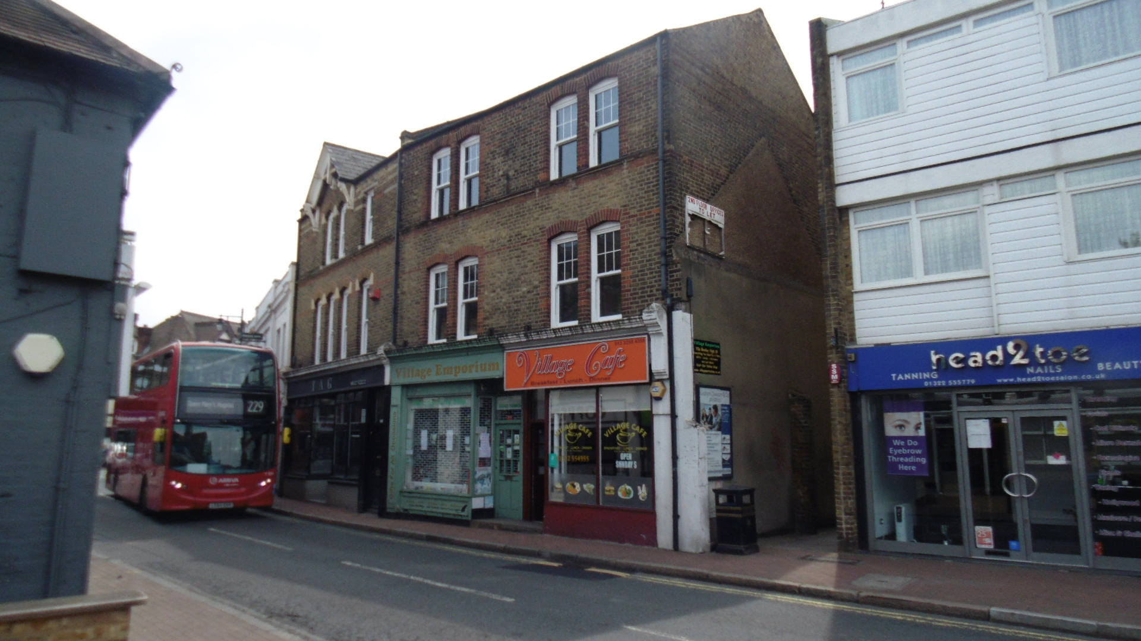

3 ground floor self -contained shops | 70, 70a, 72 HIGH STREET
Plus 2 office suites arranged over the first & second floors | BEXLEY
Part let – Projected annual income of approx. £60,000 per annum | DA5 1AJ
Ground floor areas of the 3 shops approx.175 sq. m / 1,884 sq. ft. | Tenure: FREEHOLD
First & second floor office suites of approx. 161 sq. m / 1,733 sq. ft. | Asking price: £995,000
Development potential to upper floors (STPP) | Hummerstone & Hawkins  Tel: 0208 303 1061
LOCATION:
Bexley is an area of south-east London located within the London Borough of Bexley. The village lies some 13 miles from Charing Cross and around 1.5 miles south of Bexleyheath.

Bexley High Street is a very busy local thoroughfare, with a high volume of traffic passing throughout the day and buses frequently pass the door. From the town centre there is easy access to the main A2 which connects to the M25 and the Dartford crossing. The nearby Bexley train station offers a frequent service into London Charing Cross with a journey time of between 31 and 40 minutes.

DESCRIPTION:
A prominent 3-storey end terraced freehold site with a triple road frontage situated in the centre of Bexley High Street. The property consists of on the ground floor three separate commercial together with office suites arranged over first and second floors

The access to the first and second floors are by a way of a private entrance door at the front of the building.

ACCOMODATION:
70 High Street – Café premises of approx. 52.4 square metres / 564 square feet

70a High Street – ‘A1’ retail premises of approx. 54.6 square meters / 588 square feet

72 High Street - ‘A1’ retail premises of approx. 67.91 square meters / 731 square feet

1st Floor Offices - Floor area of approx. 80 square meters / 861 square feet

2nd Floor Offices - Floor area of approx. 81 square meters / 872 square feet

TERMS:
70 High Street – Let to Village Café on a 10 year lease from 29th September 2015 at a rental of £10,500 per annum which is subject to a review on 28th September 2020.

70a High Street – Let to Village Emporium. The premises was held on a 5 year lease that ended on the 11th April 2018. We understand that recent discussion have taken place between the landlord and the tenant where the tenant has expressed a desire to agree a new lease at a rental in the region of £11,000 per annum.

72 High Street – Let to T a G on a 10-year lease until 24th March 2022 at a rental of £12,500 per annum.

1st & 2nd Floor Office Suites – The upper floors have undergone a recent refurbishment and are therefore currently vacant. We are instructed to market the office suites on 12 month licence agreements either to a single tenant or separate tenants. The asking rental of the first floor office suite is £14.500 per annum and the second floor office at £13,000 per annum.

AGENTS COMMENTS:
The first and second floor office are available on licence agreements in order that there is flexibility for an interested party to investigate the scope and potential for development and conversion.

Due to the recent lockdown we have not had the opportunity to inspect the three commercial units and therefore all measurements are approximate,

VAT:
We understand that the property is not elected for VAT

TENURE:
The property is freehold.

EPC:
The EPC’s where appropriate have been commissioned.

RATES:
The tenants are responsible for payment of the business rates.

LEGAL FEES:
Each party are to be responsible for their own legal costs

VIEWING ARRANGEMENTS:
No direct approach may be made to the property. For an appointment to view, please contact the agent.
Hummerstone & Hawkins T: 0208 303 1061

